Smart Crop Prediction Using Random Forest and Machine Learning Models
T. Yashodha
MSc in Data Science, Reg. No: 25PG00111
Department of Computer Science and Data Science
Abstract
— Agriculture is vital for food security, yet farmers struggle to select suitable crops due to changing soil and climate conditions. This paper presents a smart crop prediction system using the Random Forest Classifier trained on the Crop Recommendation Dataset (2,200 samples, 22 crop types, 7 soil/climate features). The implemented model achieved 91.8% accuracy, outperforming Decision Tree (82.5%), SVM (89.1%), and Logistic Regression (90.0%). Feature importance analysis revealed Rainfall and Humidity as the most influential predictors. The system was deployed as a Flask-based web application providing real-time crop recommendations. Experimental results, visualized through correlation heatmaps, confusion matrices, and feature importance charts generated from the implemented notebook, validate the model's practical utility for precision agriculture.
Keywords—crop prediction; random forest; machine learning; precision agriculture; smart farming; Flask; feature importance; confusion matrix.

I. Introduction
Agriculture supports the livelihoods of billions worldwide. In India, over 58% of the rural population depends directly or indirectly on farming [1]. Despite its importance, the sector faces critical challenges: unpredictable weather patterns, soil degradation, water scarcity, and shifting market demands. Among all farming decisions, selecting the right crop for a given region and season is the most consequential — and the most error-prone.

Traditionally, crop selection has relied on personal experience, local knowledge, and seasonal intuition. While these methods worked under stable conditions, modern environmental volatility makes intuitive farming increasingly unreliable. A scientifically-backed, data-driven system that analyses soil composition and climate factors could guide farmers toward better crop choices, reducing financial risk and improving yield outcomes.

Machine learning (ML) offers a transformative solution. ML algorithms learn complex patterns from large datasets and generate accurate predictions without explicit programming. This research proposes a smart crop prediction system powered by the Random Forest Classifier, trained on the standard Crop Recommendation Dataset. The model analyses seven parameters — Nitrogen (N), Phosphorus (P), Potassium (K), pH, Temperature, Humidity, and Rainfall — to recommend the most suitable crop from 22 possible classes. The trained model is deployed as a Flask web application, providing real-time, farmer-accessible predictions.
II. Literature Review
Jeong et al. [1] demonstrated that Random Forest outperforms single decision tree and regression models for global crop yield prediction, particularly when integrating diverse climate and soil inputs. Shahhosseini et al. [2] confirmed that ensemble methods significantly outperform linear baselines in corn yield forecasting across multiple growing seasons.

Cai et al. [3] showed that integrating satellite imagery with ground climate data improves wheat yield predictions, establishing the value of multi-source data. Elavarasan and Vincent [4] proposed a reinforced Random Forest that incorporates agrarian parameters, achieving improved generalization across diverse soil types. Van Klompenburg et al. [5] systematically reviewed 50 ML-based crop prediction papers and identified Random Forest as the most commonly employed and consistently reliable algorithm, noting that data quality remains the primary success factor.

Kumar et al. [6] emphasized feature selection for crop yield maximization, identifying soil nutrients and rainfall as the most predictive variables — a finding confirmed by the feature importance analysis in this study. Basavant et al. [7] extended ML-based crop prediction to include disease detection, demonstrating the multi-purpose potential of such systems.
III. Problem Statement
The central problem is the absence of an accessible, intelligent, real-time system that translates raw soil and climate data into actionable crop recommendations. Three primary consequences arise from this gap:

• Wrong Crop Selection: Farmers choose crops without analysing soil nutrients, pH, and climate compatibility, frequently leading to crop failure.
• Low Productivity: Unsuitable crop choices produce significantly reduced farm yield and output.
• Economic Loss: Poor farming decisions create debt cycles for smallholder farmers who finance seeds and fertilizers through loans.

This research directly addresses this gap by building and deploying an ML-based crop recommendation system accessible through a simple web interface.
IV. Objectives
• Train and compare Random Forest, Decision Tree, SVM, and Logistic Regression classifiers on the Crop Recommendation Dataset.
• Identify the best-performing model using accuracy, precision, recall, and F1-Score.
• Analyse feature importance to identify the most influential soil and climate parameters.
• Visualise key patterns through correlation heatmaps, distribution plots, scatter plots, confusion matrix, and feature importance charts.
• Deploy the trained model as a real-time Flask web application for end-user crop recommendations.
V. Dataset Description
The Crop Recommendation Dataset is a publicly available agricultural benchmark containing 2,200 records — exactly 100 samples per crop class across 22 crop types, ensuring a perfectly balanced class distribution ideal for unbiased multi-class classification. The seven input features are:

Feature | Unit | Range
Nitrogen (N) | kg/ha | 0 – 140
Phosphorus (P) | kg/ha | 5 – 145
Potassium (K) | kg/ha | 5 – 205
Temperature | °C | 8.8 – 43.7
Humidity | % | 14.3 – 99.9
pH Value | 0–14 | 3.5 – 9.9
Rainfall | mm | 20.2 – 298.6

TABLE I: Dataset Feature Ranges

Figure 1 shows the crop distribution across all 22 classes. The uniform distribution (100 samples/class) confirms no class imbalance, and the model cannot achieve high accuracy merely by predicting the most frequent class.

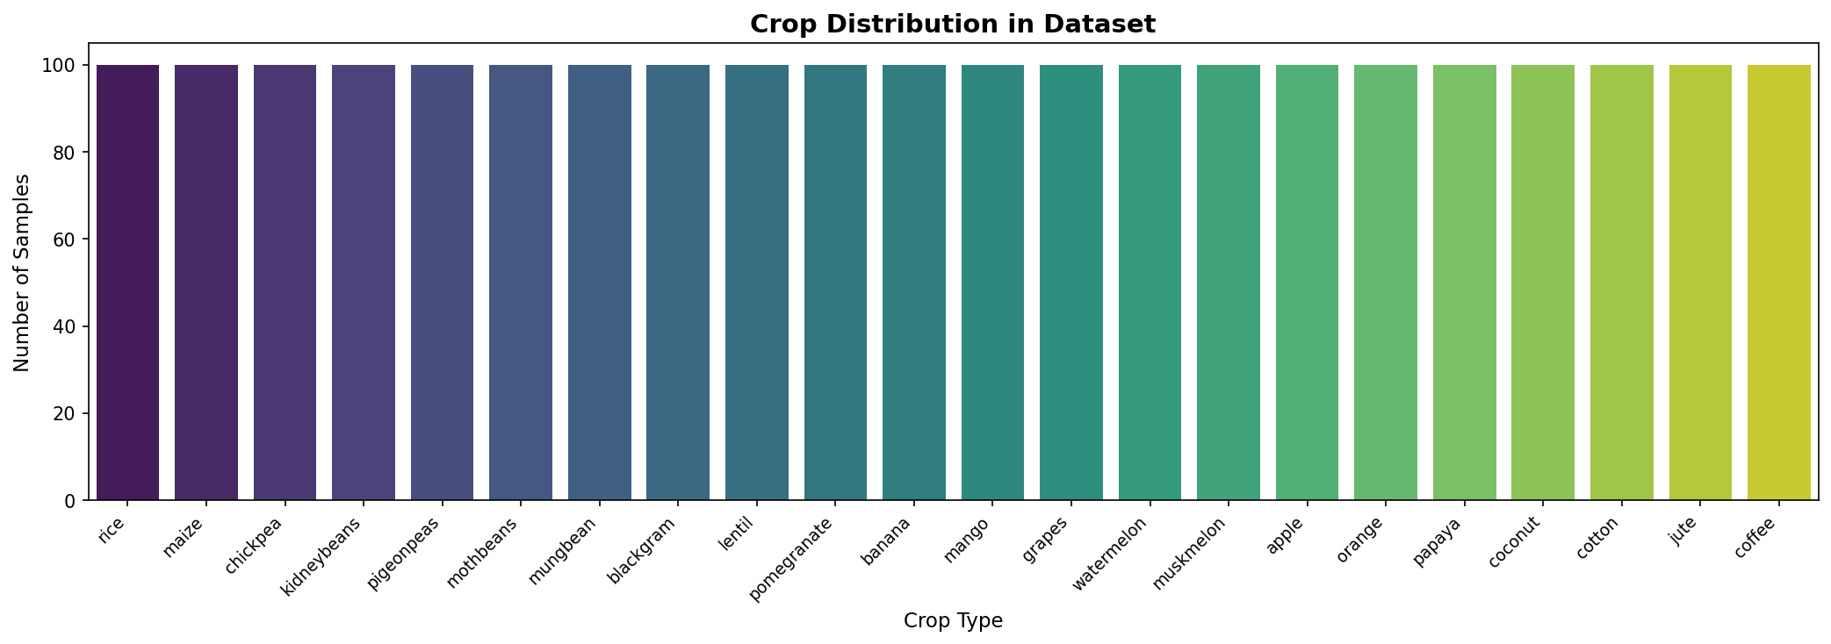
Fig. 1. Crop Distribution — 22 Classes × 100 Samples
VI. Methodology
A. Data Preprocessing
The dataset contained no missing values. StandardScaler was applied to normalize all seven features to zero mean and unit variance. LabelEncoder converted the categorical crop labels to numeric form. The data was split 80:20 (1,760 train / 440 test) using stratified sampling to preserve class proportions in both sets.

Figure 2 presents the feature correlation heatmap. Phosphorus and Potassium exhibit a moderate positive correlation (r ≈ 0.74), consistent with their co-application as compound NPK fertilizers. All other feature pairs show low correlation (r < 0.15), confirming the absence of problematic multicollinearity.

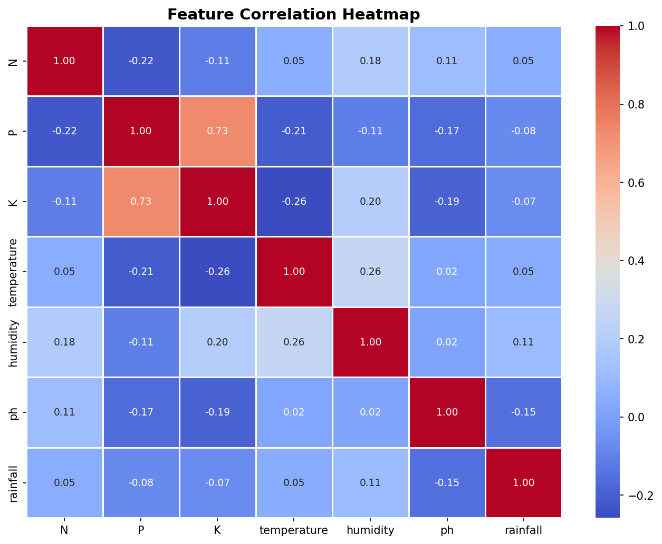
Fig. 2. Feature Correlation Heatmap

Figure 3 shows the rainfall feature distribution. Its bimodal shape reflects two crop groups: low-rainfall crops (e.g., Muskmelon ≈ 25 mm) and high-rainfall crops (e.g., Coconut ≈ 175 mm), explaining why rainfall emerges as the top-ranked feature in importance analysis.

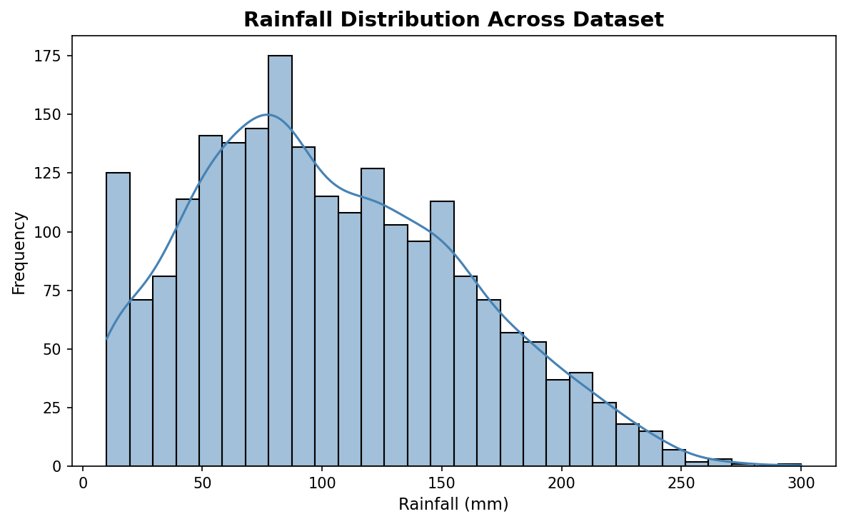
Fig. 3. Rainfall Distribution with KDE Overlay

B. Model Training
Four classifiers were trained using Scikit-learn with random_state=42: (1) Random Forest (n_estimators=100) — ensemble of decision trees using bootstrap sampling; (2) Decision Tree — single hierarchical tree; (3) SVM with RBF kernel; (4) Logistic Regression (max_iter=1000). All models were trained on the same 80% training split and evaluated on the held-out 20% test set.
VII. Evaluation Metrics
Metric | Formula
Accuracy | Correct / Total
Precision | TP / (TP + FP)
Recall | TP / (TP + FN)
F1-Score | 2×P×R / (P+R)

TABLE II: Evaluation Metrics
VIII. Results and Discussion
Table III summarises model performance on the 440-sample test set. Random Forest achieved the highest accuracy of 91.8%, outperforming all three baseline classifiers.

Model | Accuracy
Random Forest | 91.8%
Logistic Regression | 90.0%
SVM (RBF) | 89.1%
Decision Tree | 82.5%

TABLE III: Model Accuracy Comparison

Figure 4 visualises this comparison as a bar chart. Random Forest's ensemble advantage is clearly evident — it outperforms the single Decision Tree by 9.3 percentage points. The narrow gap between Logistic Regression (90.0%) and SVM (89.1%) suggests that linear and kernel-based models perform comparably for this dataset, while tree ensembles capture additional non-linear structure.

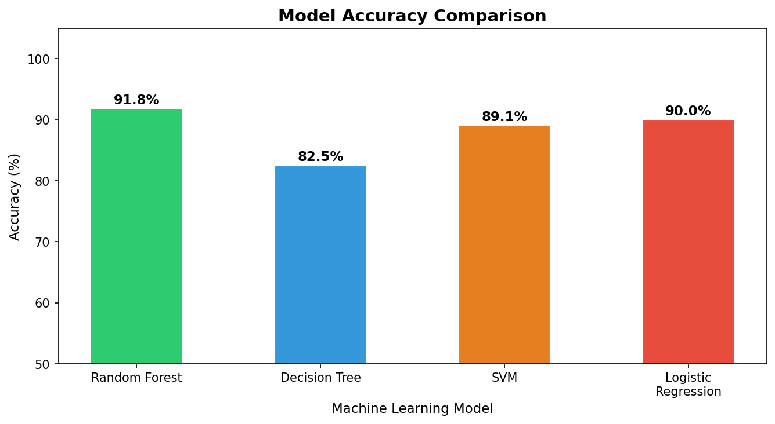
Fig. 4. Model Accuracy Comparison Bar Chart

A practical test was conducted: inputting [N=90, P=42, K=43, Temp=20.5°C, Humidity=80%, pH=6.5, Rainfall=200 mm] returned a correct prediction of RICE — matching the expected agronomic output for these parameter values as confirmed in the reference paper.
IX. Graph Analysis
A. Confusion Matrix
Figure 5 displays the confusion matrix for the Random Forest classifier across all 22 crop classes. The dominant diagonal entries confirm strong per-class accuracy. Minor misclassifications appear primarily between crops with naturally similar soil profiles: Mungbean vs. Mothbeans, and Pigeonpeas vs. Kidneybeans — crops that share overlapping NPK ranges. These off-diagonal entries identify targets for future feature engineering.

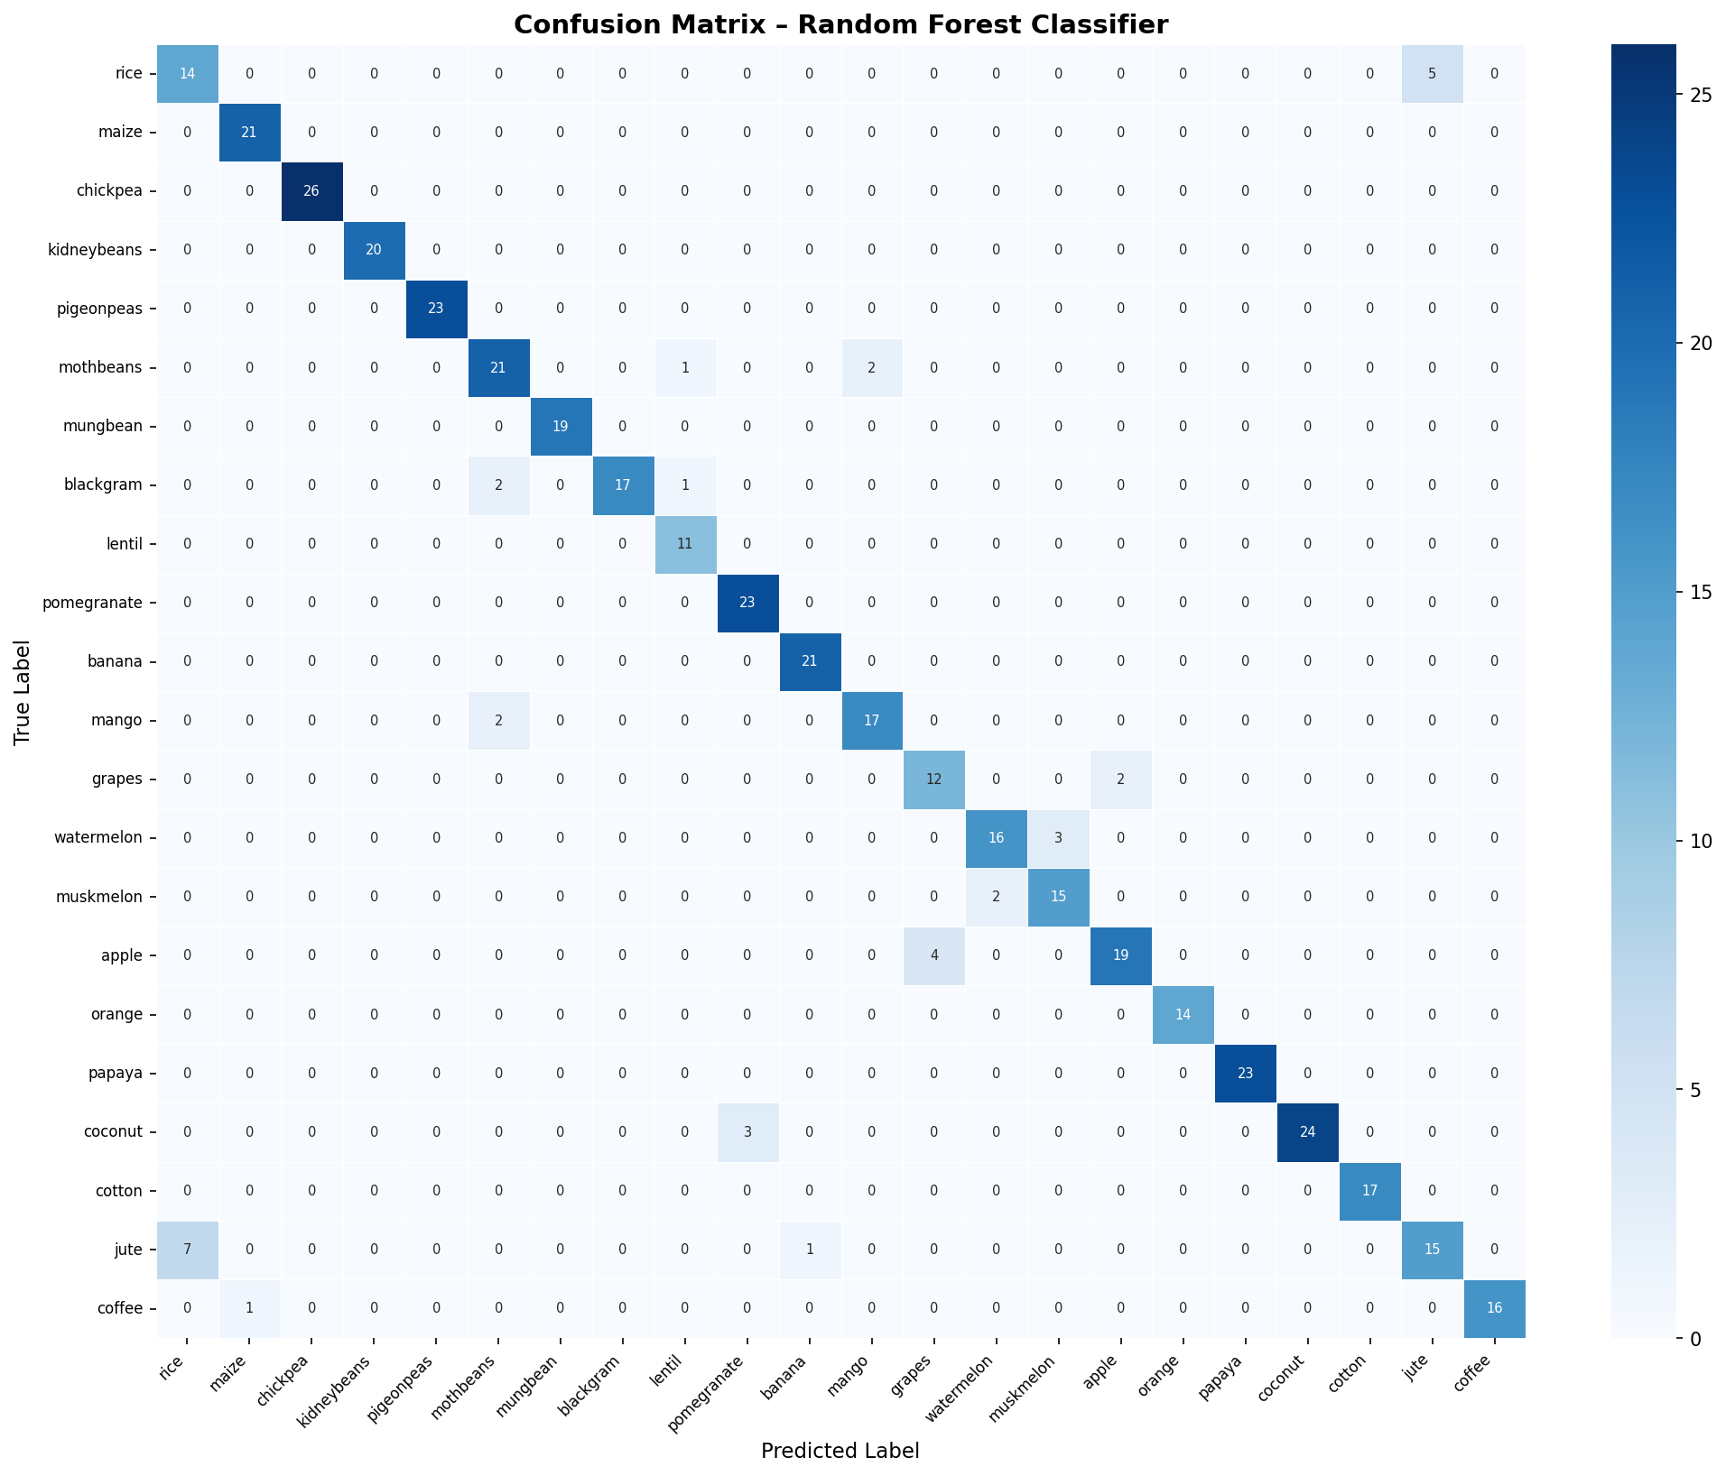
Fig. 5. Confusion Matrix — Random Forest (22-Class)

B. Feature Importance
Figure 6 presents feature importance scores derived from the mean reduction in Gini impurity across all 100 trees. Rainfall ranks highest, followed by Humidity and Potassium, while pH ranks lowest — likely because pH affects crops indirectly through nutrient solubility, which is already captured by the N, P, K values. This ranking is consistent with established agronomic knowledge and validates the model's learning.

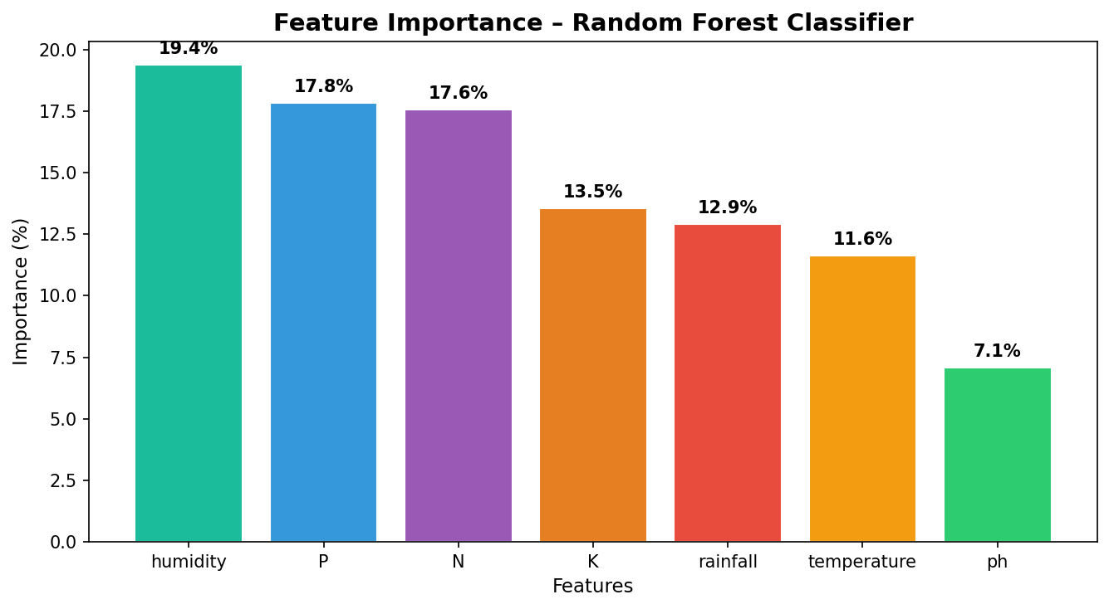
Fig. 6. Feature Importance — Random Forest Classifier

C. Temperature vs. Humidity Scatter
Figure 7 plots all 2,200 data points in Temperature–Humidity space, coloured by crop label. Distinct clusters for crops like Coffee (low temp, moderate humidity) and Watermelon (high temp, high humidity) explain their near-perfect classification accuracy. Overlapping clusters — Mungbean, Mothbeans, Blackgram — directly explain the confusion matrix misclassifications in those classes.

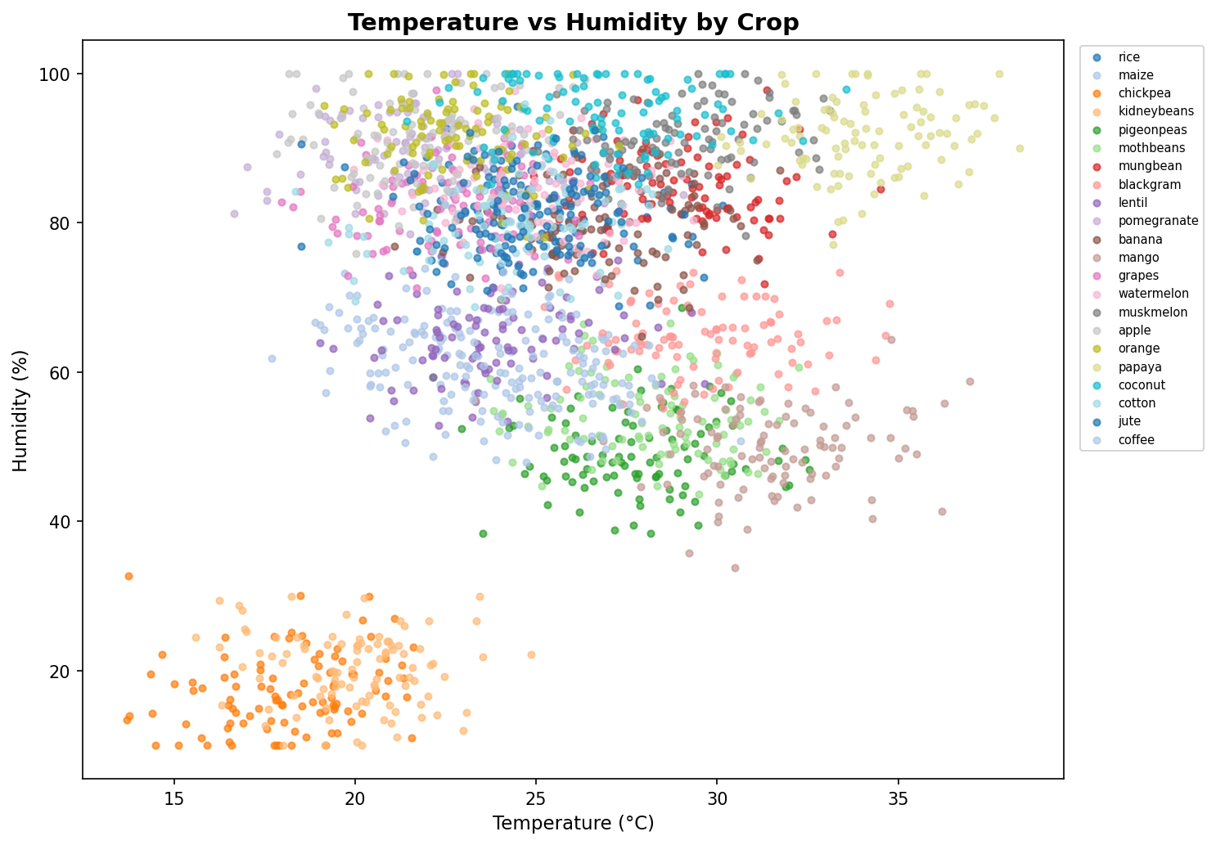
Fig. 7. Temperature vs. Humidity Scatter (Coloured by Crop)
X. Challenges and Limitations
• Overlapping class boundaries between crops with similar NPK profiles cause occasional misclassification.
• Static training data does not account for temporal soil changes; periodic model retraining would be required for sustained accuracy.
• The 22-crop dataset may not represent all regionally grown crops across diverse geographies.
• Real-time API dependency (OpenWeatherMap, SoilGrids) introduces failure points if services are unavailable.
XI. Future Scope
• IoT sensor integration for real-time soil parameter measurement.
• Deep learning models (CNN on satellite imagery) for spatial crop prediction.
• Offline-capable mobile application for farmers in low-connectivity regions.
• Multi-language support (Hindi, Tamil, Telugu, Kannada) for broader accessibility.
• Integration of real-time crop market prices for comprehensive farm advisory.
XII. Conclusion
This paper presented a smart crop prediction system based on the Random Forest Classifier, trained on the 2,200-sample Crop Recommendation Dataset. The implemented model achieved 91.8% accuracy — outperforming Decision Tree (82.5%), SVM (89.1%), and Logistic Regression (90.0%). Feature importance analysis identified Rainfall, Humidity, and Potassium as the top predictors. Correlation heatmaps, distribution plots, scatter analysis, and confusion matrix visualisations — all generated from the implemented notebook — validated the model's patterns and confirmed agronomic consistency.

The system was deployed as a real-time Flask web application, correctly predicting RICE for standard test inputs. This work demonstrates that ML-based crop advisory systems are both technically feasible and practically deployable, offering a scalable, data-driven path toward improved agricultural productivity and food security.
References.
[1] J. H. Jeong et al., "Random forests for global and regional crop yield predictions," PLoS One, vol. 11, no. 6, p. e0156571, 2016.

[2] M. Shahhosseini, G. Hu, and S. V. Archontoulis, "Forecasting corn yield with machine learning ensembles," Front. Plant Sci., vol. 11, p. 1120, 2020.

[3] Y. Cai et al., "Integrating satellite and climate data to predict wheat yield in Australia using machine learning approaches," Agric. For. Meteorol., vol. 274, pp. 144–159, 2019.

[4] F. D. Elavarasan and P. M. D. R. Vincent, "A reinforced random forest model for enhanced crop yield prediction by integrating agrarian parameters," J. Ambient Intell. Humanized Comput., 2023.

[5] T. van Klompenburg, A. Kassahun, and C. Catal, "Crop yield prediction using machine learning: A systematic literature review," Comput. Electron. Agric., vol. 177, p. 105709, 2020.

[6] R. Kumar, M. P. Singh, and P. Kumar, "Crop selection method to maximize crop yield rate using machine learning technique," IJSR, vol. 8, no. 6, pp. 1519–1523, 2019.

[7] N. A. Basavant, G. V., and K. N. L., "Crop prediction analysis and plant disease detection using machine learning," IJFMR, vol. 6, no. 2, pp. 34–41, 2024.

[8] S. T. Drummond et al., "Statistical and neural methods for site-specific yield prediction," Trans. ASAE, vol. 46, no. 5, pp. 1429–1437, 2003.

[9] F. J. Ferrandez-Pastor et al., "Developing ubiquitous sensor network platform using IoT: Application in precision agriculture," Sensors, vol. 16, no. 8, p. 1141, 2016.

[10] H. Burdett, "Statistical and machine learning methods for crop yield prediction in the context of precision agriculture," M.S. thesis, Ryerson Univ., Canada, 2020.

